CTM-I Use Case

Parm Browse

Version 0.1

Use Case Name | Parm Browse
Actor | App Support
Pre-conditions /Assumptions | User has Browser and is aware of the http path to the application.  User has successfully logged into the CTM-I application.  User has the right role to see the menu options.
Post Conditions | None
Screenshot | 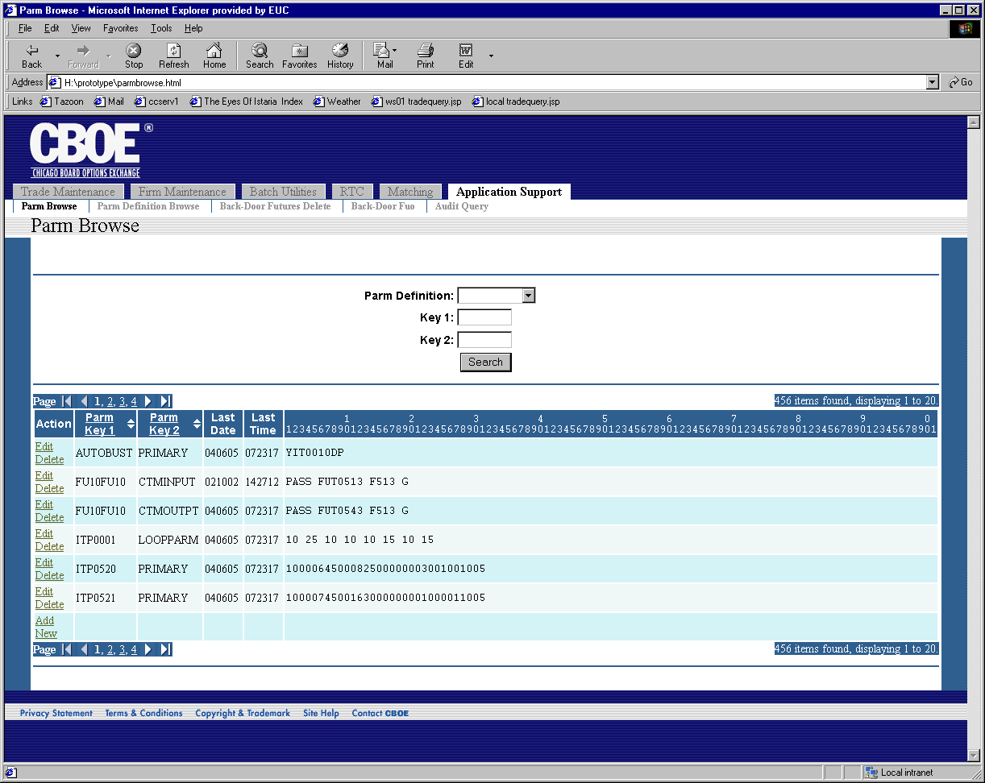
Flow of Events | - User selects “Parm Browse” from the menu.  - Parm Browse screen displays  - The selects the criteria for the list of parms to retrieve.  - Parm Definition – List of the valid Parm Definitions  - Key 1 – value to search for in the Key 1 field, a wildcard is appended to the value.  - Key 2 – value to search for in the Key 2 field, a wildcard is appended to the value.  - User presses the search button to get a list of parms.  - If a Parm Definition is selected, the Dynamic Parm Browse Use Case is activated.  - A request is sent to CTM-R to retrieve the list of parms that match the criteria.  - The list of parms retrieved from CTM-R is displayed on the Parm Browse screen in table format. The table is read-only. The table contains the following fields  - Parm Key 1  - Parm Key 2  - Last Date  - Last Time  - Parm Data – Displays in a fixed width font that displays the column position as a header.  - The table will contain standard paging.  - The table will be sortable by Parm Key 1 and Parm Key 2 fields.  - An action is available to delete a row. Using this action will first prompt the user for confirmation of the delete. Once the user confirms the delete, the delete is sent to CTM-R to process. Once the delete is complete, a search with the previous criteria is performed.  - An action is available to edit a row. This action triggers the Generic Parm Edit Use Case.  - An action is available to add a row. This action triggers the Generic Parm Add Use Case.
Alternative Path | None.

